**NIKE INC. EXTERNAL ANALYSIS.**

**By (Njoroge Zacharia)**

Table of Contents

**Executive summary3**

**1.0 Industrial PESTLE analysis of the sportswear industry** 3

**2.0 Porters 5 force analysis**8

**3.0 Markets and critical success factors12**

**4.0 Opportunities and threats in footwear industry** 19

**5.0 Strategic position of Nike** 21

**6.0 The key issues that are related to the future of the company**24

**7.0 Two possible future strategies for Nike** 24

**8.0 References**29

**Executive summary**

The paper incorporates PESTEL exploration, of the 5 forces of porter’s analysis for the footwear industry with a decision of whether the industry is attractive for the companies that are already in the industry. The paper also looks at the market profits prediction for Nike in the next 4 years and the footwear revenue prediction for the next 4 years. The threats as well as opportunities which are concerned with Nike Inc. are discoursed with strategic position and future strategic recommendations for the company which will results to the success of the company through performance improvements.

**1.0 Industrial PESTLE analysis of the sportswear industry**

Political

1. There are changes that takes place for example, the usage application of small interest charges, the global levy agreements that are applied to reduce the amount of tax that the companies in the sportswear industry has to pay to operate in those countries.[1](#page4) (Müller, 2017, pg2066-2092)
2. There are political conflicts that takes place between countries and within countries. For example the cold trade war that has been going on between china and USA. This has resulted into imposition of tariffs on the goods from either sides therefore increasing their cost of operations. This has greatly affected Nike Inc. since the products from USA are heavily taxed in china making the companies like Nike to make a lot of losses.[2](#page4)( Jolkkonen, 2018)
3. Müller, D., 2017. The role of brand communities within the athletic footwear industry: an assessment of selected brand communities with a focus on the Swiss athletic footwear industry.
4. Jolkkonen, A., 2018. Market entry to United States for woodworking hobbyist product.

Economic factors

1. Market failure as well as collapse involves consumers switching to other sportswear products that they perceive to be cheaper as compared to the well-known brands that they consider to be expensive. Due to this reason, the sales of Nike Inc., since customers have switched to other brands such as reebok as they think Nike is expensive.3 (Mahajan, 2020)
2. There is an increasing labour costs making the production operation cost to be higher in such nations for the sportswear companies carry out their operations. For example, the Nike Company has been experiencing increased labour costs in the eastern countries since the cost of labour has been increasing with time.4 (Silva, 2019)
3. The well-known sportswear brands such as Nike Inc., Adidas, and reebok have accumulated tremendously enough financial resources that is able to make them penetrate the emerging small markets so as to increase their sales and revenue earnings. 2(Jolkkonen, 2018)

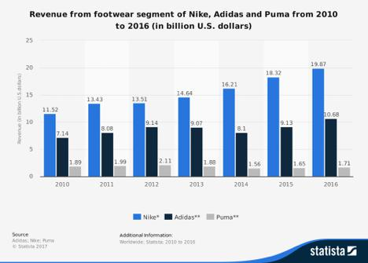

Social factors

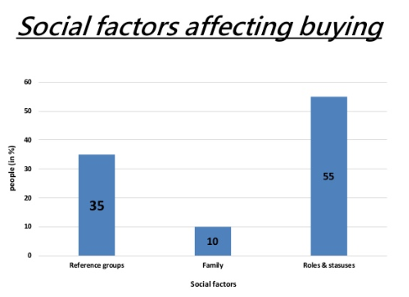

1. Due to the rise of health care health care awareness have made people in the entire world to have interest in buying sports apparel so that they can do daily exercise so as to keep them fit and healthy. Therefore, this directly affects Nike since Nike is likely to tap this emerging customers since it is one of the well-known brands. 1(Distelhorst, et al., 2017).
2. There have been criticism of the non-procedural, dubious and non-standard production processes. Thus, this can likely reduce the status of the companies in the sportswear industry. This has affected Nike Inc., directly since it has been accused of dubious production processes. 2(Mahajan, 2020).

Technical factors

1. The technological advancement has for a long time helped the companies in this industry to innovate and come up with new way of doing things and creating new products thus increasing the productivity and performance of the company’s [4](#page8)(Walia, 2019).
2. The recent year spread of the social media platforms has made the sports companies to market their product as well as brand and services that they deal with. Such platforms as Facebook, we-chart. This has ensured that Nike and the other companies has made their brands well known worldwide hence making them to increase their sales [5](#page8)(Distelhorst, et al., 2017).
3. Through the help of technology, opportunities have been made available to utilize use of the valued as well as info established metrics which aims to enhance the production output as well as maximizing revenue accumulation (Brohi, et al., 2016).

Environmental factors

Mass production of the sportswear products has made the companies in to emit dangerous gases into the atmosphere such as carbon dioxide. This has endangered the lives of people and animals. At the same time, the mass production has made the companies to dump waste materials and chemicals into the surrounding rivers and water bodies engendering the lives of living organisms and also the lives of human beings exposing them to danger of having diseases associated which are waterborne. This directly affects Nike and it has made the environmental protection agencies to overtax the company making them to lose a lot of revenues to the taxation agencies[6](#page9)(Mahajan, 2020).

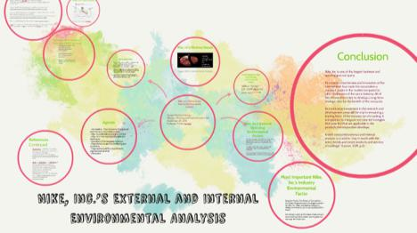

Nike have impact on the environment through emission of carbon as well as operational surroundings for workers. Therefore, the company poses lot of threats to the well-being of human beings. For instance, the environmental issues are produced during the manufacturing phase where shoe industries use machinery as well as chemicals to produce shoes. Fossils fuel is used to make the machines run thus, producing greenhouse gases. Also during transportation, carbon dioxide is produced thus posing a threat. In general, the manufacturing phase, poses lot of environmental threats which are harmful for the living organisms as well as aquatic organisms. The graph below show the carbon emission from various phases of production.

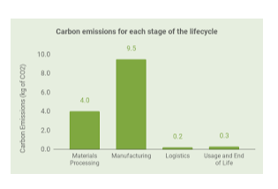

**2.0 Porters 5 force analysis**

Nike Inc. focusses on three main strategic business units that the company puts most of its energy so as to maximize its revenue accumulations. These include: footwear, apparel and equipment. Out of the above three SBUs, footwear is the strongest SBU that Nike focuses on and it contributes to the company’s larger proportion of revenue. Nike Inc. footwear takes a market share of 35 percent in the entire footwear market (Nike Inc., 2014)

We are going to focus on footwear as a strategic business unit for the purpose of carrying out porters 5 forces analysis in the industry. In the case of Nike, the five forces porters’ model stresses that competition is a very significant and fundamental external factor for Nike’s external operations. As far as footwear is concerned, there are other brands that are making the competition in this SBU to be very stiff such as Adidas and reebok. These other companies are trying so much to innovate and come up with more improved shoes so that they can also increase their market share and make the market to be competitive (Yao, 2019).

1. Competitive rivalry (strong force) - this explains the effect that competition has on Nike footwear operations as well as other firms in the industry. There is a lot of competition in the sports footwear industry and the strong force of competitive rivalry is contributed by low growth rate of markets, the firms in this industry and business unit such as Adidas are very aggressive making the competitive rivalry to be very strong (Merikanto, 2019).
2. Bargaining power of the customer ( this is a moderate force). Nike’s customers that are buying the sports footwear products have a moderately stronger bargaining power due to the fact that: there is very small switching charges, the substitutes of the footwear products which are produced by other companies and delivered to the market (Vos, 2018)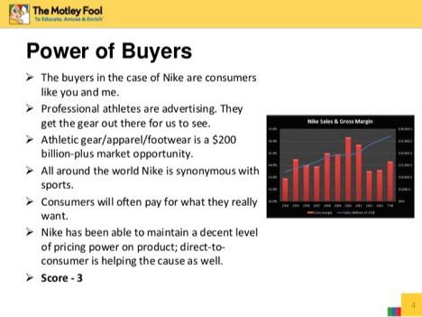
3. Bargaining power of the supplier (weak force). The sellers who supply the Nike with the materials they use as inputs in the manufacturing the footwear products have a very weak bargaining power due to higher number of overall suppliers who are readily available and willing to supply the materials at the market price resulting to higher overall supply. (Jiang, 2019).
4. 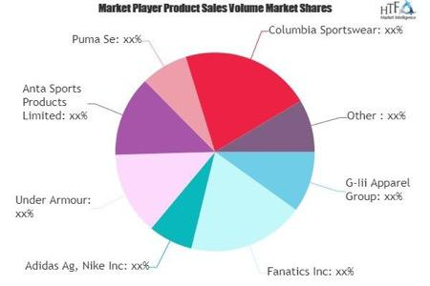Threat of substitutes- this is a moderate force. There is a moderately stronger force of threat of substitutes to the footwear products due to: moderate availability of substitutes from the other companies such as adidas, there is also moderate performance per price of the substitutes and also there is a very low cost of switching from one product brand to another. This makes it very dangerous for the company in business since customers can easily substitute their footwear products. (Marques, and Moschatou, 2017).
5. Threat of new entrants (a weak force) – the entrance of a new supplier in the market results to threats into the sporting footwear industry is not very harmful as well as strong and this has not been a nightmare to Nike Inc. the threat of entry into the industry is weak due to: very expensive and costly to develop a brand, there is also high cost associated with carrying out the footwear business. Cost of developing the brand is also high making it very difficult for other firms to enter and carry out this kind of business ( Merikanto, 2019).

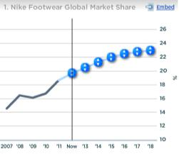

The footwear strategic business unit is therefore a very attractive business unit since it is characterized by very high competition, and very high rate of substitutes. The fact that there is weak bargaining power of suppliers and also there is weak threat of entry into the market, the firms that are already in the field are advised to continue operating since they are assured of profitability with moderate competitors since there is less firms having the necessary resources to develop the brand and carry out business. Therefore, the firms that are already in the market, dominate the market.

**3.0 Markets and critical success factors**

|  |  |  |
| --- | --- | --- |
| Year | Revenue in billions | % increase or decrease |
|  |  |  |
| 2019 | 39.117 | 7.47% |
|  |  |  |
| 2018 | 36.397 | 5.59% |
|  |  |  |
| 2017 | 34.35 | 6.1% |
|  |  |  |
|  |  |  |

Source: Nike Inc. 2019 annual report.

The regression analysis is given by

SUMMARY OUTPUT



*Regression Statistics*

**

|  |  |
| --- | --- |
| Multiple R | 0.996695 |
| R Square | 0.9934 |
| A d j u s t e d R |  |
| Square | 0.9868 |
| Standard Error | 0.274751 |
| Observations | 3 |
|  |  |

ANOVA



*Significa*

*do* *SS* *MS* *F* *nce F*

**

|  |  |  |  |  |  |  |  |  |  |  |
| --- | --- | --- | --- | --- | --- | --- | --- | --- | --- | --- |
|  |  | 11.362 | | 11.362 | 150.51 | |  |  |  |  |
| Regression | 1 | 14 |  | 14 | 56 |  | 0.051776 |  |  |  |
|  |  | 0.0754 | | 0.0754 |  |  |  |  |  |  |
| Residual | 1 | 88 |  | 88 |  |  |  |  |  |  |
|  |  | 11.437 | |  |  |  |  |  |  |  |
| Total | 2 | 63 |  |  |  |  |  |  |  |  |
|  |  |  | |  |  |  |  |  |  |  |
|  |  |  | |  |  |  |  |  |  |  |
|  |  | *Standa* | |  |  |  |  |  |  |  |
|  | *Coefficie* | *r* | *d* |  | *P* | *-* | *L o w e r* | *U p p e r* | *Lower* | *U p p e r* |
|  | *nts* | *Error* |  | *t Stat* | *value* |  | *95%* | *95%* | *95.0%* | *95.0%* |
|  |  |  | |  |  | |  |  | |  |
|  |  | 392.05 | | -12.17 | 0.0521 | |  | 208.23 -9754. | | 208.23 |
| Intercept | -4773.28 | 38 |  | 51 | 72 |  | -9754.8 | 39 | 8 | 39 |
|  |  | 0.1942 | | 12.268 | 0.0517 | |  | 4.8520 | -0.085 | 4.8520 |
| X Variable 1 | 2.3835 | 78 |  | 48 | 76 |  | -0.08504 | 41 | 04 | 41 |
|  | |  |  |  |  |  |  |  |  |  |
| The regression equation is | |  |  |  |  |  |  |  |  |  |
| Y=-4773.28+ 2.3835 X | |  |  |  |  |  |  |  |  |  |
| FOUR PREDICTIONS FOR THE INDUSTRY | | | | |  |  |  |  |  |  |
| 2020= -4773.28+ 2.3835X | |  |  |  |  |  |  |  |  |  |

REVENUE = 2850.13 BILLION

2021=-4773.28+ 2.3835X

REVENUE= 2850.54 BILLION

2022= -4773.28+ 2.3835X

REVENUE= 2050.97 BILLION

2023= -4773.28+ 2.3835X

REVENUE= 2851.39 BILLION

FOR THE foot wear SBU

|  |  |
| --- | --- |
| YEAR | Revenue in millions |
|  |  |
| 2018 | 22268 |
|  |  |
| 2017 | 21081 |
|  |  |
| 2016 | 19871 |
|  |  |
| 2015 | 18318 |
|  |  |
| Source: Nike Inc., 2019 annual report. |  |

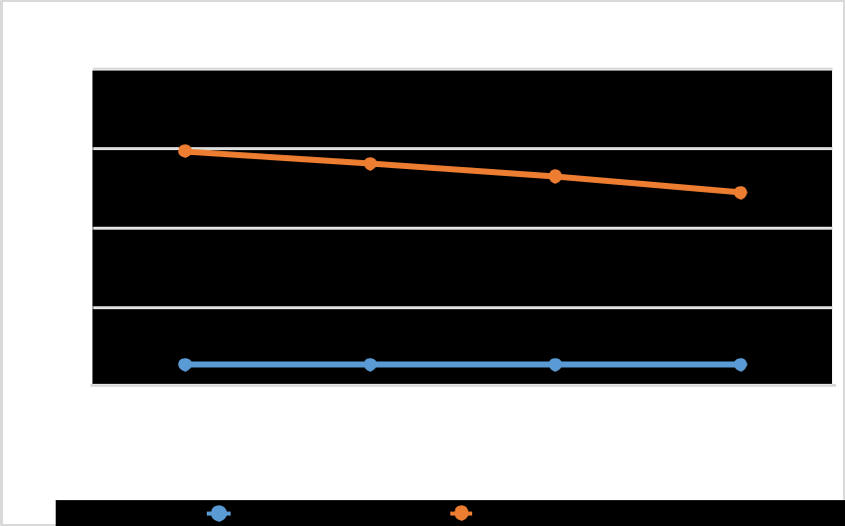

line grapg

30000

22500

15000

7500

0

|  |  |  |  |
| --- | --- | --- | --- |
| 1 | 2 | 3 | 4 |
| YEAR |  | Revenue in millions |  |

NIKE INC. 18

|  |  |  |  |  |
| --- | --- | --- | --- | --- |
|  | scatter diagram for year and revenue | | |  |
| 23000 |  |  |  |  |
| 17250 |  |  |  |  |
|  | y = 1306x - 2.613E+6 | |  |  |
| 11500 |  | R² = 0.9955 |  |  |
|  |  |  |  |
| 5750 |  |  |  |  |
| 0 |  |  |  |  |
| 2014 | 2015 | 2016 | 2017 | 2018 |

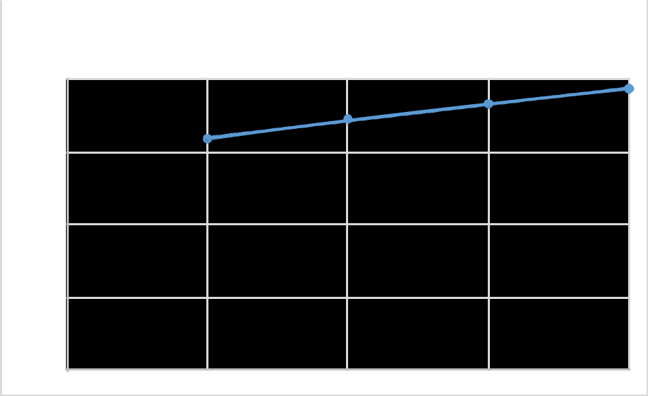

Figure1: correlation of year and revenues

Equation is y=10.109x; x- year, y revenue.

Regression analysis

SUMMARY

OUTPUT



*Regression Statistics*

**

|  |  |
| --- | --- |
| Multiple R | 0.997744 |
| R Square | 0.995493 |
| Adjusted | R |

Square

S t a n d a r d

Error

Observations



0.99324

138.9406

4

ANOVA



NIKE INC. 19



|  |  |  |  |  |  |  |  |  |  |
| --- | --- | --- | --- | --- | --- | --- | --- | --- | --- |
|  |  |  |  |  | *Significan* |  |  |  |  |
|  | *do* | *SS* | *MS* | *F* | *ce F* |  |  |  |  |
|  |  |  |  |  |  |  |  |  |  |
|  |  | 852818 | 852818 | 441.77 |  |  |  |  |  |
| Regression | 1 | 0 | 0 | 16 | 0.002256 |  |  |  |  |
|  |  |  | 19304. |  |  |  |  |  |  |
| Residual | 2 | 38609 | 5 |  |  |  |  |  |  |
|  |  | 856678 |  |  |  |  |  |  |  |
| Total | 3 | 9 |  |  |  |  |  |  |  |
|  |  |  |  |  |  |  |  |  |  |
|  |  |  |  |  |  |  |  |  |  |
|  | *Coefficie* | *Standar* |  |  | *L o w e r* |  | *Upper* | *Lower* | *Upper* |
|  | *nts* | *d Error* | *t Stat* | *P-value* | *95%* | *95%* | | *95.0%* | *95.0%* |
|  |  |  |  |  |  |  | |  |  |
|  |  | 125297 | -20.855 | 0.0022 |  | -20740 | | -31522 | -20740 |
| Intercept | -2613165 | .5 | 7 | 91 | -3152276 | 53 | | 76 | 53 |
|  |  | 62.136 | 21.018 | 0.0022 |  | 1573.3 | | 1038.6 | 1573.3 |
| X Variable 1 | 1306 | 14 | 36 | 56 | 1038.65 | 5 | | 5 | 5 |
|  |  |  |  |  |  |  |  |  |  |

The regression equation is given by

Y= -2613165 + 1306X; Y- the revenue, X- the year.

Predicting the next 4 years market information

2020= -2613165+ 1306x

Revenue= 2002.438744million

2021= -2613165+ 1306x

Revenue= 2002.43951 million

2022= -2613165+ 1306x

Revenue=2002.440276 million

2023= -2613165+ 1306x

NIKE INC. 20

Revenue= 2002.441041 million

**Critical success issues that customers demand from the companies in the footwear SBU**

Customers in the footwear industry expects the companies in this market to focus on some critical success factors that needs to be addressed to as to meet their needs thus remain to be loyal to them. SOME OF THE KEY SUCCESS FACTORS that they expect include: (Gürel, and Tat, 2017)

1. Production of high quality goods which are strong as well as durable materials. The customers expect the companies in the footwear industry to make strong shoes that will be able to last longer without wear and tear.

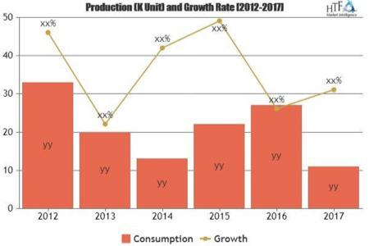

1. The customers also expect the companies to sell their products at a reasonable price so that not to spend a lot of money buying. Therefore, it is upon the companies such as Nike to minimize their production and operation costs so that they can sell to their consumers at a reasonably cheaper price.
2. Comfort- the customers expect the companies in the footwear industry to make those shoes and footwear that make the consumers feel comfortable whenever they use them for their sports activities.
3. Brand image- consumers also expect the companies to build a strong brand image so that they can always feel proud to be associated with their brand since better brand image is associated with very high quality products.
4. Unique design- customers expect the company of their choice to come up with sportswear products that are of unique design and exemplary and very different from ordinary shoes; associated with a particular class.
5. ordinary shoes; associated with a particular class.

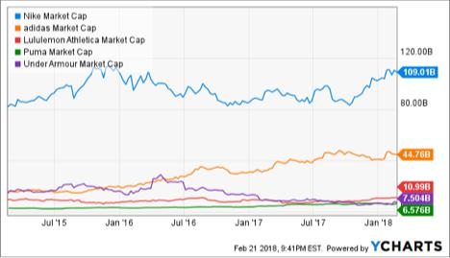

**4.0 Opportunities and threats in footwear industry**

**Opportunities.**

1. Since Nike has accumulated much more resources, the company can be able to increase its product mix so as to provide a wide variety of products. The company can use the resources at its disposal to carry out R&D so as to identify alternative products that can be availed to its customers so that it can increase it variety.( Childs, and Jin, 2018)
2. The company can also take advantage of its resource endowment so as to widen its

Operations to the developing countries where the market is still untapped[7](#page22). (Jolkkonen, 2018)

1. The company can immensely improve its labour and employment practices so that it does away with employment controversies and this will immensely improve its image. (Mahdi, et al., 2015, pg167-177)
2. The company can also take advantage of the current advancement in technology so as to carry out data analytics and identify market trends, to also use social medial and digital platforms to increase its market share. ( PANDEY, 2017)
3. Childs, M. and Jin, B., 2018. Nike: An Innovation Journey. In *Product Innovation in the* *Global Fashion Industry* (pp. 79-111). Palgrave Pivot, New York.
4. The company also has the opportunity to take advantage of the strong brand image it has so as to produce a variety of products with high quality features so as to attract more customers.( Jolkkonen, 2018)

**Threats**

1. There is a threat of competition from other players in the industry such as adidas that are present in the market. ( Mahdi, et al., 2015, pg167-177, pg167-177)
2. The rapid technological advancement also possess threat to Nike Inc. since the pother players in the industry may make use of this technological advancement to come up with better products than Nike hence disadvantaging the company[8](#page23).[9](#page23) (Walia, 2019)
3. There is also threat of imitation where other players are imitating the products of Nike and using their logo so as to make their products and sell. This is very damaging to the company.[10](#page23)( Childs,and Jin, 2018)
4. There is also a threat of employment controversies where employees are complaining of racism, unequal opportunities and lack of fairness in the company. This is likely to destroy the image of the company and reduce, market share.( Walia, 2019)
5. Threat of political instability in other countries for example in the developing African countries that can disrupt business. ( Mahdi, et al., 2015, pg167-177, pg167-177)



1. Walia, K., 2019. Sneakers Market Size and Share Report 2018 to 2025.

There is high threat to the company due to high technological innovation making companies to heavily innovate.

**5.0 Strategic position of Nike**

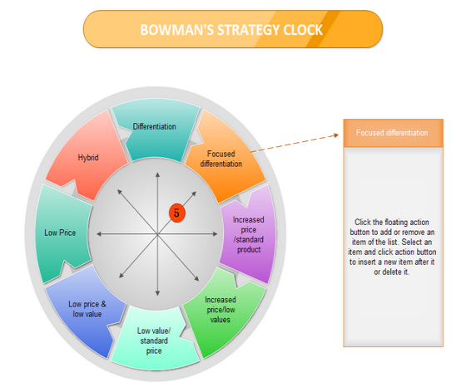

In the Bowman’s strategic clock, Nike Inc. is I position three, which is the second top most position in this strategic clock. Here, the company is using a hybrid strategy that is characterized by moderate price and the moderate product differentiation strategies. Nike is attracting its customers by offering to them products at reasonable prices and also they incorporate some product differentiation characteristics that is not offered by the other brands such as adidas in the market. This is a very efficient strategy for brand positioning since Nike constantly offers added valuation 11(Quinn, and Hilmer, 1994).

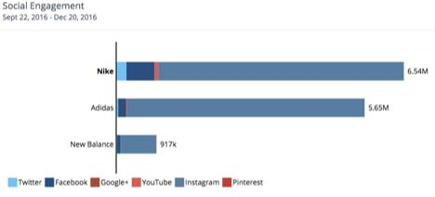

The company has also adopted constant marketing strategy using different platforms and also investment in R&D so as to find out the market trends and also the tastes and preferences of the consumers so that they can come up with those products that suite the needs and requirements of the consumers. (Duarte, 2018

[11](#page25) Quinn, J.B. and Hilmer, F.G., 1994. Strategic outsourcing. *MIT Sloan Management* *Review*, *35*(4), p.43.

By **the theory of Ansoff matrix**, Nike Inc. is using the following strategies so as to carry out its activities.

Market penetration strategies- Nike is trying to attract new users / customers to buy their products and also encouraging their already existing customers to continue buying through proper advertisement and marketing.[12](#page26)( Duarte, 2018)

Product development- Nike has the potential to develop new types of products in the market through in[13](#page26)novation and this is likely to attract new users of these products and is likely to attract the old users to buy the products. This strategy may also not be very productive especially if awareness is not properly carried out.

Market development- Nike is not affected by new market development since they often sell and promote their products in the already known market and also invest their resources to sell in the new markets through averts.

Diversification- the company is currently dealing in specific products though they have the capacity to diversify in other areas and other products. Therefore the company needs to abandon the old strategy of focusing on specific products to specify in the variety of products to increase their market cap.

their market cap.

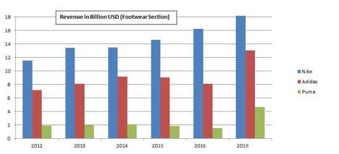

**6.0 The key issues that are related to the future of the company**

Some of the issues that are currently related to the future of Nike include

1. Lack of diversity in the product mix[14](#page27)- the company is not having a wider variety of products in its disposal as compared to the other players such as adidas. This is likely to affect the company in future since customers like to get all they want under one roof. The company is very innovative and has invested in innovation and through R&D, the company is likely to deal with this in future and develop more products so as to avail a variety of products. (Childs, and Jin,2018.)[15](#page28)
2. The controversies as far as labour and employment practices are concerned. Nike is having a lot of issue as far as fairness, diversity in employment is concerned. The company needs to develop a framework that sill help them solve such like issues in the various branches all over the world so that they can employ in terms of competency and not based on ethnicity, racism and social status. The company current business model is not addressing this and therefore it needs to come up with such a framework to help it[1617](#page28). (Ranjan, 2016)

The company is in a very good position to face the future because:

The company has invested much of its resources in research and development so as to find out the current market trends and also to find out the problems facing the company such as lack of diversification and lack of proper employment and labour law implementations. The company by following all the findings from the research is likely to solve such problems and increase their market position. (Ranjan, 2016)[18](#page28)

**7.0 Two possible future strategies for Nike**

* 1. product differentiation to take it into position 4 in the bowman’s strategy clock- through product differentiation strategy, the company needs to come up with those strategies that will make sure that the company’s products are completely unique from those of their competitors. This will also make sure that the issues that are related to imitation are also avoided since the company will have very unique product elements that are very complex to imitate.[19](#page29) This strategy is acceptable and very feasible since it only need the company to come up with the unique differentiation elements and features that they need to put into place so as to make them unique.[20](#page29) (Ranjan, 2016)
  2. The company also need to strengthen the supplier and customer intimacy. This strategy will makes user that the company facilities and improve customer loyalty so that they have very loyal customers and suppliers that will also act as brand ambassadors. Through this, the company will have more customers in place that will be able to buy their products and also will reduce their expenditure in marketing since their loyal customers and suppliers will be able to advertise for hem by word of mouth. This strategy is also feasible and very acceptable since the company only needs to produce products that satisfy the needs of their customers and also improve on their customer relation and customer care services[21](#page29).( Childs, and Jin, 2018)

Out of the above two strategies, the winning strategy is the second one: strengthening the supplier and customer intimacy since this will make sure that the company has ready market for the newly produced products and also they will be able to spend less in advertisement and marketing but at the same time, the company will be able to increase its sales and revenue accumulation due to the increased number of customers and through the customer relations that has been built properly[22](#page30).( D'Agostino, 2018)[23](#page30)

FEASIBILITY AND ACCEPTABILITY

Feasibility

|  |  |  |
| --- | --- | --- |
| strategy | Financial | Resource development |
|  |  |  |



|  |  |  |  |  |  |  |  |  |  |
| --- | --- | --- | --- | --- | --- | --- | --- | --- | --- |
|  |  |  |  |  |  |  |  |  | NIKE INC. 31 |
|  |  | | | | |  | |  |  |
| P r o d u c t | The company | | | | | can | | take | Through integration and efficiency in supply |
| differentiation | part | of | | the | | financial | | | chain management which are necessary. |
|  | resources | | | | generated | | | | Innovation and creativity will make sure that |
|  | f r o m | | i t s | | r e v e n u e | | | | the capacity of Nike has been improved and |
|  | accumulations. | | | | | |  |  | expanded to increase production. |
|  | The company can also | | | | | | | |  |
|  | get finances from loans | | | | | | | |  |
|  | they | obtain | | | | from | | say |  |
|  | c e n t r a l b a n k o f | | | | | | | |  |
|  | American | | | | and | | other | |  |
|  | financial lenders. | | | | | |  |  |  |
| Strengthening of | T h e d e p a r t m e n t | | | | | | | o f |  |
| c u s t o m e r a n d | m a r k e t i n g | | | | | | a n d | |  |
| supplier intimacy | advertisement | | | | | will | | be |  |
|  | a c c o r d e d p a r t o f | | | | | | | |  |
|  | finances | | | through | | | | the |  |
|  | budgeting | | | process | | | | that |  |
|  | will be used to improve | | | | | | | |  |
|  | customer | | | relations | | | | and |  |
|  | supplier intimacy. | | | | | |  |  |  |
|  |  |  |  | | |  | |  |  |
| SBU | R&D |  | costs | | | that | | are |  |
|  | related to the process of | | | | | | | |  |
|  | finding | | the trends in the | | | | | |  |
|  | footwear market so as to | | | | | | | |  |
|  | find the best preferences | | | | | | | |  |
|  | that |  | the | | public | |  | may |  |
|  | want. |  |  |  |  |  |  |  |  |
|  |  |  |  |  |  |  |  |  |  |

Acceptability

|  |  |  |  |  |  |
| --- | --- | --- | --- | --- | --- |
| **strategy** | **Risk vs. return** | | | **S t a k e h o l d e r s** | **Accept / reject** |
|  |  |  |  | **reaction** |  |
|  |  |  | |  |  |
| **Corporate** | **Product** | **differentiation** | | **Stakeholders were** | **accept** |
| **strategies** | **has the** | **risk of being** | | **pro the idea and they** |  |
|  | **identified** | | **especially** | **agreed to help in this** |  |
|  | **w h e n t h e** | | **p r o d u c t** | **source-sing the funds** |  |
|  | **becomes** | **faulty in the** | | **that are required and** |  |
|  | **hands of the customers.** | | | **the employees are** |  |
|  | **But the returns will be** | | | **ready to help in the** |  |
|  | **that the** | **differentiation** | | **entire process.** |  |
|  | **will give** | **the company** | |  |  |
|  | **the uniqueness and its** | | |  |  |
|  | **quality will be identified** | | |  |  |
|  | **without any problem** | | |  |  |
|  |  |  |  |  |  |

|  |  |  |  |  |  |
| --- | --- | --- | --- | --- | --- |
|  | The company also need to | | | **T h e s t a k e h o l d e r s** | **accept** |
|  | strengthen the supplier and | | | **fully supported the** |  |
|  | customer intimacy. | | The | **idea** |  |
|  | risk that are involved is | | |  |  |
|  | loosing customers | | when |  |  |
|  | things are not done the | | |  |  |
|  | right was. The | suppliers | |  |  |
|  | are also likely | to | shift |  |  |
|  | their allegiance | to | other |  |  |
|  | c o m p a n i e s w h e n n o t | | |  |  |
|  | handled with care | |  |  |  |
|  |  |  |  |  |  |

**Some of the key issues in implementing this strategy include: (**Childs, and Jin, 2018)

1. The customers are likely to exploit the customer relation strategy put by the company and use it for their own benefits.
2. The competitors may be aware of this customer intimacy stray and they may decide to also use prior to Nike Inc.

3) The customers may demand for balance of power.

**8.0 References**

D'Agostino, J.L., 2018. *The Impact of E-commerce on Brands: An Analysis of Amazon and a* *Plan for the Future* (Doctoral dissertation, University of Oregon).-

Müller, D., 2017. The role of brand communities within the athletic footwear industry: an assessment of selected brand communities with a focus on the Swiss athletic footwear industry.

Jolkkonen, A., 2018. Market entry to United States for woodworking hobbyist product.

Silva, D.T.D.M., 2019. *Equity research-Nike, Inc* (Doctoral dissertation, Instituto Superior de E c o n o m i a e G e s t ã o ).

[Mahajan, S., 2020. Sneakers Market Size & Share Analysis Report, 2019-2026.](https://scholar.google.com/scholar?hl=en&as_sdt=0%252C5&q=Mahajan%252C+S.%252C+2020.+Sneakers+Market+Size+%2526+Share+Analysis+Report%252C+2019-2026.&btnG=)

Distelhorst, G., Hainmueller, J. and Locke, R.M., 2017. Does lean improve labor standards? Management and social performance in the Nike supply chain. *Management Science*, *63*(3), pp.707-728

Walia, K., 2019. Sneakers Market Size and Share Report 2018 to [2025.](https://scholar.google.com/scholar?hl=en&as_sdt=0%252C5&q=Walia%252C+K.%252C+2019.+Sneakers+Market+Size+and+Share+Report+2018+to+2025.&btnG=)

Brohi, H., Prithiani, J., Abbas, Z., Bhutto, A. and Chawla, S., 2016. Strategic Marketing Plan

[of Nike.](C:\\Users\\USER\\Downloads\\of  Nike.https:\\scholar.google.com\\scholar?hl=en&as_sdt=0,5&q=Brohi,+H.,)

Yao, D., 2019. *Nike* [*inc.-footware*](https://scholar.google.com/scholar?hl=en&as_sdt=0%252C5&q=Yao%252C+D.%252C+2019.+Nike+inc.-footware+and+apparel+%2528Doctoral+dissertation%2529.&btnG=) *and apparel (Doctoral* [*dissertation).*](https://scholar.google.com/scholar?hl=en&as_sdt=0%252C5&q=Yao%252C+D.%252C+2019.+Nike+inc.-footware+and+apparel+%2528Doctoral+dissertation%2529.&btnG=)

Merikanto, S., 2019. Controversal Marketing-A successful strategy to grow a brand or ra p p r o a c h ? C a s e s t u d y : N i k e I n c .

Vos, D.A., 2018. Nike Flagship Façade–Design, Engineering and Testing. *ce/papers*, *2*(5-6), pp.205-215.

Jiang, W., 2019. Sustainable Development of Supply Chain in Footwear Industry–Take Nike as the Case. *Asian Business Research*, *4*(3), p.86.

Marques, A.D. and Moschatou, A., 2017, October. Learning process in fashion design students: link with industry and social media. In *IOP Conference Series: Materials Science* *and Engineering* (Vol. 254, No. 23, p. 232005). IOP Publishing.

Gürel, E. and Tat, M., 2017. SWOT analysis: a theoretical review. *Journal of International* *Social Research*, *10*(51).

PANDEY, B.C., 2017. *Nike Inc-Complete Analysis: SWOT, PESTLE and Marketing strategy*.

BookRix.

Mahdi, H.A.A., Abbas, M., Mazar, T.I. and George, S., 2015. A Comparative Analysis of Strategies and Business Models of Nike, Inc. and Adidas Group with special reference to C o m p e t i t i v e A d v a n t a g e i n t h e c o n t e x t o f a D y n a m i c a n d C o m p e t i t i v e Environment. *International Journal of Business Management and Economic Research*, *6*(3), pp.167-177.

Quinn, J.B. and Hilmer, F.G., 1994. Strategic outsourcing. *MIT Sloan Management* *Review*, *35*(4), p.43.

Duarte, G., 2018. *Nike inc* (Doctoral dissertation).

Ranjan, W., 2016. The Financial Performance Analysis of Nike Inc: with Special Reference Ye a r 2 0 1 5 A n n u a l R e p o r t.

Childs, M. and Jin, B., 2018. Nike: An Innovation Journey. In *Product Innovation in the*

*Global Fashion Industry* (pp. [79-111).](https://scholar.google.com/scholar?hl=en&as_sdt=0%252C5&q=Childs%252C+M.+and+Jin%252C+B.%252C+2018.+Nike%253A+An+Innovation+Journey.+In+Product+Innovation+in+the+Global+Fashion+Industry+%2528pp.+79-111%2529.+Palgrave+Pivot%252C+New+York.&btnG=) Palgrave Pivot, New [York.-](https://scholar.google.com/scholar?hl=en&as_sdt=0%252C5&q=Childs%252C+M.+and+Jin%252C+B.%252C+2018.+Nike%253A+An+Innovation+Journey.+In+Product+Innovation+in+the+Global+Fashion+Industry+%2528pp.+79-111%2529.+Palgrave+Pivot%252C+New+York.&btnG=)